11th International Conference on GiT4NDM
Abstract Template
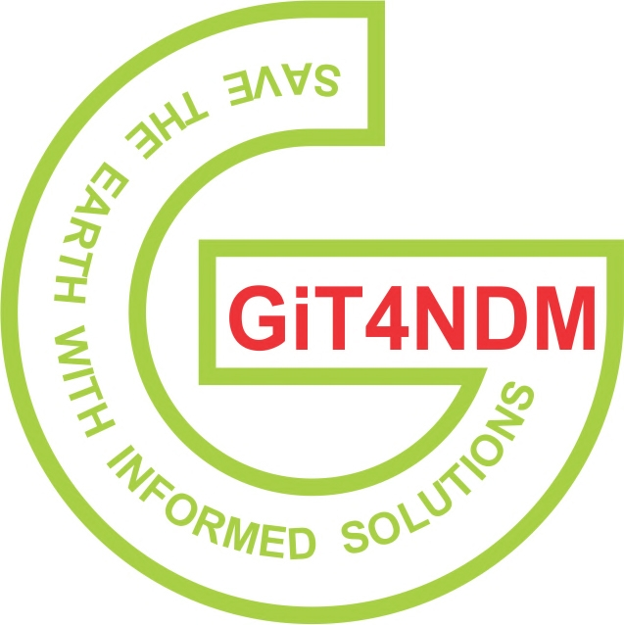

Title of Abstract
(Bold, centered, concise, and informative) [14 pt font]
Author(s) Name(s) [10 pt font]
Full name of author 1¹, author 2², author 3¹
¹Affiliation, Department, University/Organization, Country
²Affiliation, Department, University/Organization, Country
Corresponding author email: example@domain.com [8 pt font]
Abstract [12 pt font]
Maximum 250-300 words unless otherwise specified.
Provide a clear and concise summary of the research, including background, objectives, methodology, key findings, and main conclusions. The abstract should be written in a single paragraph without citations or references. [10 pt font]
Keywords [12 pt font]
List 4-6 keywords separated by commas. Example: GeoAI, Remote Sensing, Machine Learning, Disaster Management, Spatial Analysis [10 pt font]
Guidelines
- Use Times New Roman, 10-12 pt font
- Single-spaced text
- Do not include figures, tables, or references in the abstract
- Ensure clarity, originality, and relevance to conference themes
- Submit in Word format (.doc or .docx)

